Chris Ricchi

November 11 2023

Probability and Applied Stats

**Normal, Beta, and Gamma Distributions**

**Abstract:** This research paper delves into three fundamental probability distributions: the Normal Distribution, Gamma Distribution, and Beta Distribution. Each distribution is explored in terms of its definition, purpose, real-life applications, and discussed from a mathematical standpoint in terms of their probability mass functions (PMF) or probability density functions (PDF). The Normal Distribution, often characterized by its bell-shaped curve, finds itself in diverse real-world applications such as psychology, physics, and even finance. Its symmetrical shape gives it effective modeling in various different fields. The Gamma Distribution, a model of continuous variables, is a crucial tool of engineering and mathematical theory. With the ability to model a waiting time in occurrence to a number of specific events, the Gamma Distribution contributes heavily to the analysis of complex problems. Lastly, the Beta Distribution, another model of continuous variables, is best represented in random variables that denote proportions or probabilities. It finds itself mainly in applications where outcomes are inherently bounded. This research paper aims to provide a comprehensive understanding of these distributions, exploring their mathematical foundations and practical implications. Readers will gain insights into the probabilistic outcomes of these distributions and comprehend grounded statistical modeling analysis.

**The Normal Distribution**

The continuous Normal Distribution (ND), commonly referred to as the Gaussian distribution, is a continuous probability distribution characterized by its symmetrical bell-shaped curve defined by the parameters mean ($μ$) and standard deviation ($σ$). Originally developed from the Central Limit Theorem, the ND represents the behavior of the sum or average of a large number of independent random variables transcending the original distribution’s shape. It stands as a fundamental concept in applied statistics with a large array of real-world applications, such as biological measurements, educational testing, and finances. It can help assess biological measurements such as height, weight, and blood pressure in human populations to assess health-related trends. The ND allows for the establishment of percentiles and comparison of individual test takers educational environments. Even in finance, the ND is commonly used to model the distribution of stock prices and investment returns. One common financial model, called the Black-Scholes option pricing model, is based around the ND in the sense that the variables pertaining to the model follow a normal distribution. The ND also informs risk assessment and portfolio management through its influence on stock prices and returns. The PDF for the ND is as follows:

$$f(x; μ, σ)=\frac{1}{\sqrt{2π}}{ e^{-\frac{1}{2}(\frac{x-μ}{σ})}}^{2}$$

Whereas $f(σ, μ)$ denotes the density function itself, which represents the probability per unit length on the horizontal axis; f(x) is a representation of the random variable we are calculating, and $μ / σ$ represent the mean and standard deviation respectively. The denominator of the PDF is a constant in relation to the shape of the ND, ensuring the area under the curve is always equal to 1. The exponential term e is what gives the distribution its bell-shaped curve. It involves the squared difference between the random variable (x) and the mean ($μ$) normalized by the standard deviation ($σ$). The PDF captures the likelihood of observing a particular value with its parameters $σ and μ$ shaping the distribution’s location. Notably, because the ND is a continuous distribution, it lacks a probability mass function (PMF), but has a variance of $σ^{2}$ in the bounds of ($σ, μ$). The normal distribution helps quantify many uncertainties making it a key tool in statistical modeling.

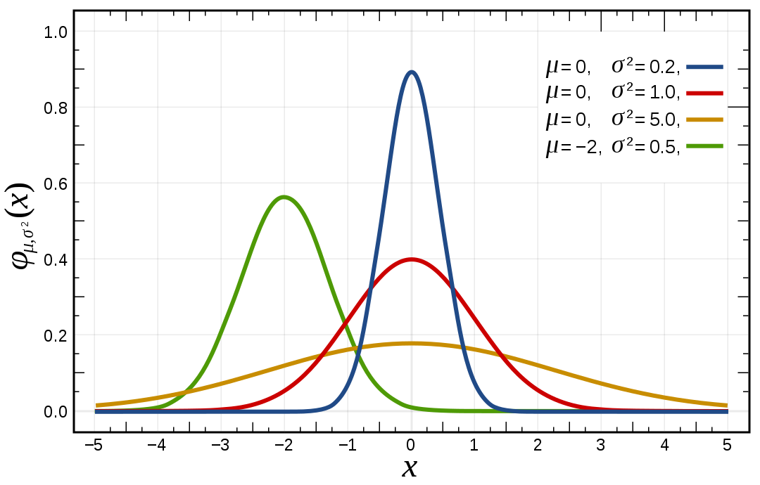

**The Gamma Distribution**

The continuous Gamma Distribution (GD), a versatile probability distribution, is one of the most relevant distributions in statistical theory and modeling. The GD offers a distinct framework from the normal distribution. While the ND is characterized by its symmetrical bell-shaped curve, the GD diverges in its focus on modeling the waiting time until a specific number of events occur. Defined by shape and scale (k, $θ$), the GD finds applications in various fields, most specifically in engineering and mathematical theory. It is frequently employed to model the time until a system or component fails its functionality. For instance, a scenario where we measure the time it takes for a brand new light bulb to burn out follows a Gamma Distribution. Engineers can use this dataset to analyze the reliability of that brand of light bulb and make informed decisions about maintenance or warranties. The GD is often seen in mathematical theory, more specifically in queueing. If we consider a call center and how many calls they get per hour, we could use the GD to build a model of inter-arrival times of customers or calls to predict wait times and help design the system in a more efficient manner. GD can apply to a larger variety of scenarios, such as predicting cell division, analyzing traffic flow, measuring annual rainfall, and even measuring drug relapses. The PDF for the GD is as follows:

$$f(x; k, θ)=\frac{1}{Γ(k)θ^{k}}x^{k-1}e^{\frac{-x}{θ}}$$

Whereas $f(k, θ)$ denotes the density function itself, where x is the random variable for which we are calculating the probability density. The variables k and $θ$ are parameters that characterize the shape and scale of the distribution. The initial fraction in the PDF is a normalization factor which ensures that the area under the curve is equal to 1, similar to the ND. The variable $Γ(k)$ is the gamma function evaluated at k, which is a generalization of the factorial function; this part is what ensures proper scaling of the distribution. In the denominator, the $θ^{k}$ represents the scale of the distribution which exponentially increases. Multiplying the fraction by $x^{k-1}$ gives the distribution its shape, whereas x is the random variable and k-1 changes the skewness and tail behavior of the distribution. The last part of the PDF, the $e^{\frac{-x}{θ}}$, allows the distribution to decay as x increases. This determines the rate at which the probability decreases with increasing values of x. The variance of the Gamma Distribution is $var=kθ^{2}$, which provides a measure of how spread out the values are in terms of the mean. The variance of the GD is directly proportional to the shape of $k$. As $k$ increases, the variance increases with it. In short, the PDF for the Gamma Distribution helps capture the probability density of the assigned random variable x based on the distribution’s specific shape (k) and scale ($θ$). The gamma function $Γ$, the normalization factors, and the exponential term between x and $θ$ define the GD, making it a valuable tool that is used worldwide in applied statistics.

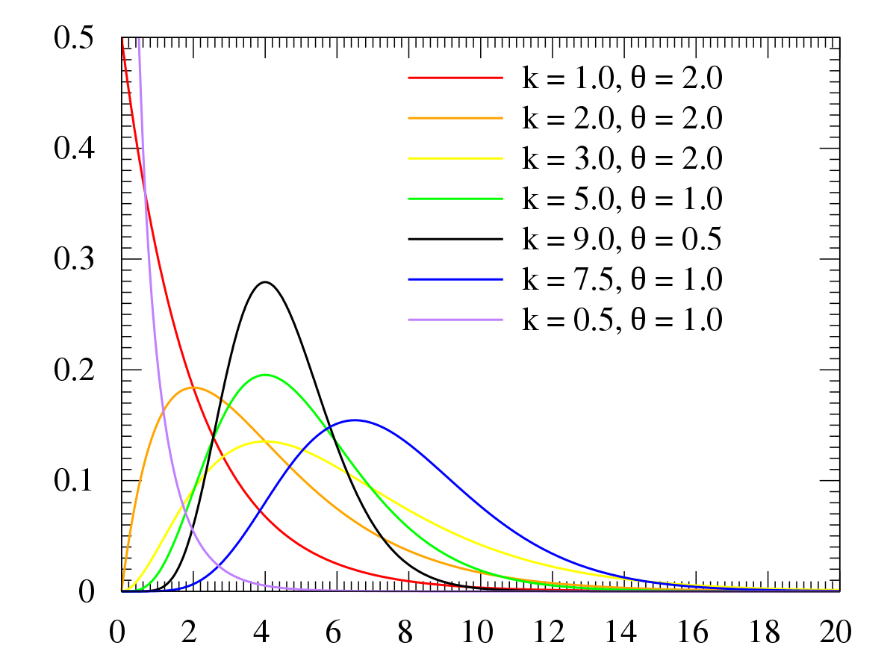

**The Beta Distribution**

The continuous Beta Distribution (BD) stands as a distinct model within applied statistics. The BD is employed to model random variables bounded within the unit interval [0, 1]. Defined by the shape parameters $α$ and $β$, the Beta Distribution is quite similar to the Gamma Distribution and finds itself in similar real-world applications, specifically in the engineering and mathematical fields. One relevant application the BD can assist with is building a model to predict the proportion of defective items in a manufacturing process. More specifically, the BD can model the probability of a system failing within a specified time. The BD can also extend its use to less broad applications, such as in the biology field where it can be used to predict proportions of different cell types in a population. The Beta Distribution is more adaptable than the Gamma and Normal Distributions, making it a valuable standalone tool for predictable probabilities and constrained outcomes. The PDF for the BD is as follows:

$$f(x; α, β)=\frac{x^{α-1}(1-x)^{β-1}}{B(α,β)}$$

Whereas $f(α, β)$ denotes the density function itself, where x is the random variable for which the probability density is being calculated for. The parameters $α$ and $β$ are the shape parameters of the distribution, and $B(α, β$) is the beta function. Similar to the ND and the GD, this beta function ensures that the total area under the curve is always equal to 1. $x^{a-1}(1-x)^{β-1}$ represents the likelihood of observing a specific value x in the distribution. The exponents $a-1$ and $β-1$ determine the shape and influence the skewness and tail behavior of the distribution. The function contains variance at $var[X] = \frac{αβ}{({α+β)}^{2}(α+β+1)}$ which provides a measure of how dispersed the values of the BD are in terms of the mean. The $αβ$ numerator signifies the interaction between the two shape parameters and $(αβ)^{2}(a+β+1)$ is a normalization factor to scale the distribution properly. The Beta Distribution PDF is mainly used for modeling proportions, probabilities and constrained outcomes.

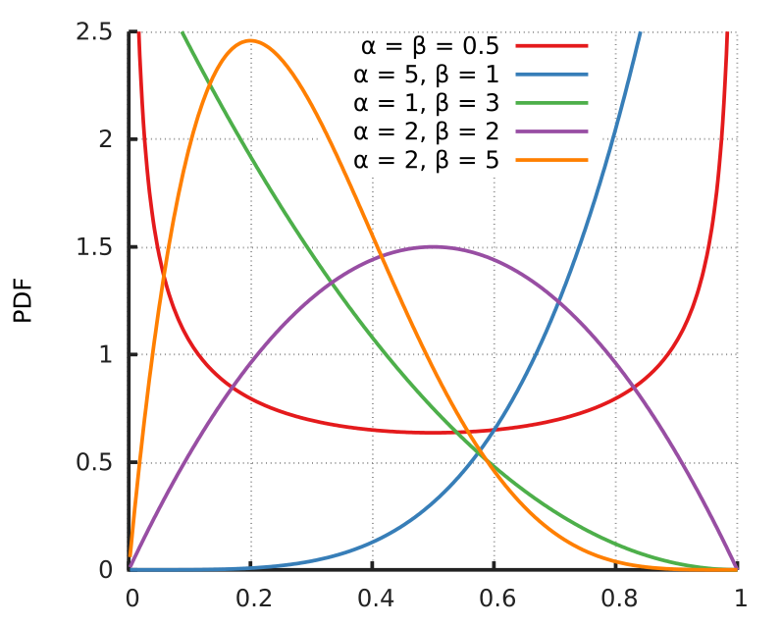

**Understanding the Results**

Gaining a comprehensive understanding of the three probability distributions (Normal, Gamma, Beta) unveils patterns, trends, and uncertainties in data, giving you the ability to use them to model, predict, and optimize outcomes. Whether it be the intricacies of the Normal Distribution, the waiting times of the Gamma Distribution, or the bounds of the Beta Distribution, all each have their own respective use in the world of mathematics, engineering, and sciences. The variance of the distributions provides a scope to cater each probability density function to the parameters required. Furthermore, use of the variance and density functions allows researchers to discern the reliability of their results, emphasizing the importance of the distributions. Using these distributions has given researchers the opportunities to extract more insight from the field of probabilistic research that can help us understand more about the world around us.

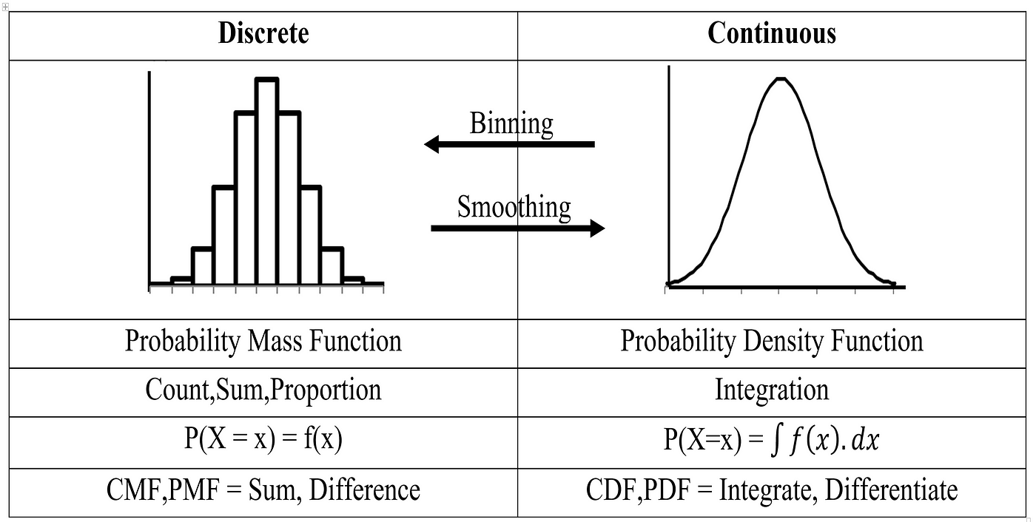

***All sources provided below.***

**SOURCES**:

<https://en.wikipedia.org/wiki/Normal_distribution>

<https://en.wikipedia.org/wiki/Beta_distribution>

<https://en.wikipedia.org/wiki/Gamma_distribution>  
<https://testbook.com/maths/gamma-distribution#:~:text=Gamma%20distributions%20are%20common%20in,and%20the%20results%20are%20skewed>.

<https://towardsdatascience.com/beta-distribution-intuition-examples-and-derivation-cf00f4db57af>

<https://www.scribbr.com/statistics/normal-distribution/#:~:text=All%20kinds%20of%20variables%20in,few%20examples%20of%20such%20variables>.